**HOMEWORK 4**

Problem 1.

Create a Web Page like the following. Write your own to do list!

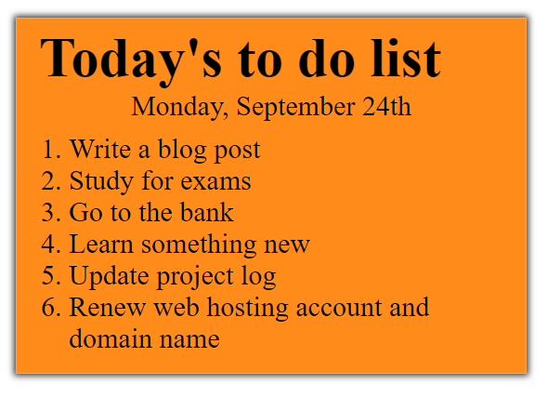

Create two files: "**to-do-list.html**" and "**to-do-list.css**"

### Constraints

* **<div>** with **class="my-list"** as container
  + Background color: **#ff8c1a;**
  + Padding: **8px 24px**;
  + Width: **500px**;
  + Text size: **30px;**
  + Border: **1px solid #ffa64d**;
  + box-shadow: **0 0 10px 2px #333333;**
* **<ol>**
  + Margin: **12px;**
* **<p>**
  + Center the text

Problem2.

Create a Web Page like the screenshot below.

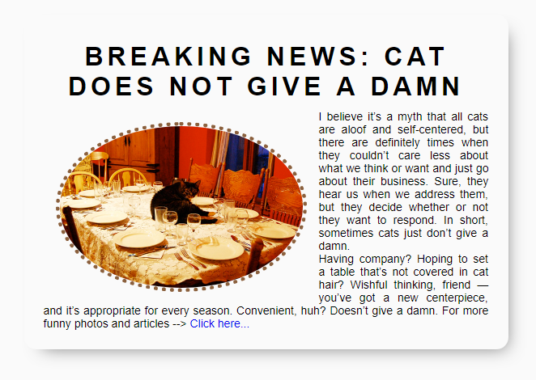

Create two files: "**simple-article.html"** and **"simple-article.css".** Use **semantic HTML** to create HTML the page.

### Constraints

* **<body>**
  + **font-family:"Lato", sans-serif;** [**"https://fonts.googleapis.com/css?family=Lato:300,400,900"**](https://fonts.googleapis.com/css?family=Lato:300,400,900)
* Content
  + Width: **550px;**
  + Border radius: **15px;**
  + Center the **content**
  + Padding: **25px;**
  + Background color: **#fafafa;**
  + **box-shadow: 10px 11px 35px -14px rgba(0,0,0,0.54);**
* **<h1>** tag for heading
  + Margin bottom: **0;**
  + Padding: **10px;**
  + Text center
  + Letter spacing: **5px;**
* **Image**
  + Width: **200px;**
  + Border radius: **50%;**
  + Margin: **15px;**
  + Border: **5px dotted #8b603d;**
  + Use “**left floating**” for the image: <https://css-tricks.com/almanac/properties/f/float/>
* **Paragraphs**
  + Text size: **14px;**
  + Use “**text-align: justify**” to align the text left and right (learn more at <http://www.w3schools.com/css/css_text.asp>).

Problem 3.

Create a Web Page like the following or create your own idea (*Bonus*)!

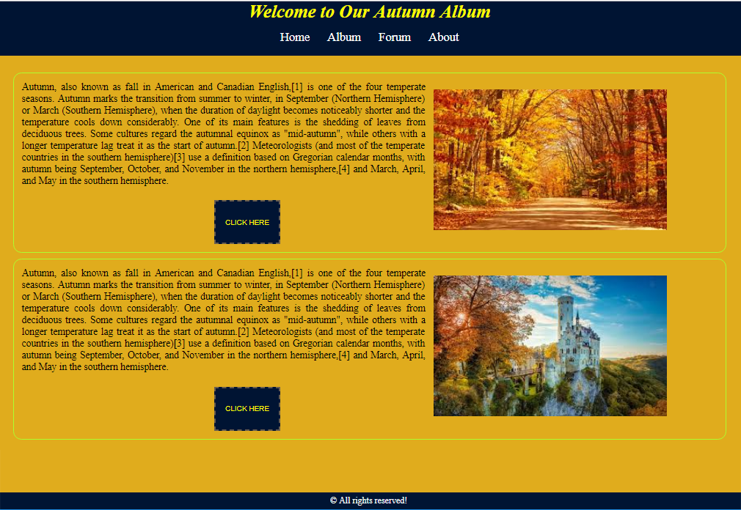

Create files: "**Golden-Autumn.html**" and "**Golden-Autumn.css**"

### Constrains

* **<body>**
  + Background: **#bc6c09;**
* **<p>**
  + Color : **black**;
  + Font-size : **18px**;
* **<h1>**
  + Padding:**5px**;
  + Color: **yellow**;
  + Italic
* **<header>**
* background-color: #001433;
* color: #fff;
* font-size: 22px;
* text-align: center;
* padding: 0;
* margin:0;
* **<section>**
  + Height: **900px**;
  + Padding: **20px**;
  + Margin on top : **100px**;
  + Background**: #e0ac1d**;
  + Radius on border: **15px**;
  + Text-align**: justify**;
  + Text-justify: **inter-word**;
* **Button**
  + Border: **2px dashed**;
  + Border-Color: **#685d50**;
  + Background: **#001433**;
  + Color :**yellow**;
  + Width: **120px**;
  + Height: **80px**;
  + Left margin: **350px**;
  + Top margin: **25px**;
  + Uppercase the text
* **Make hover on <a> and <button>**
  + Color: **red**;
  + Background: **#e8f3f4**;
  + Italic
* **<footer>**
  + Color: **white**;
  + Center the text
  + Padding: **15px**;
  + Background: **#001433**;